Northern Schools Early Years Cluster Kindergarten
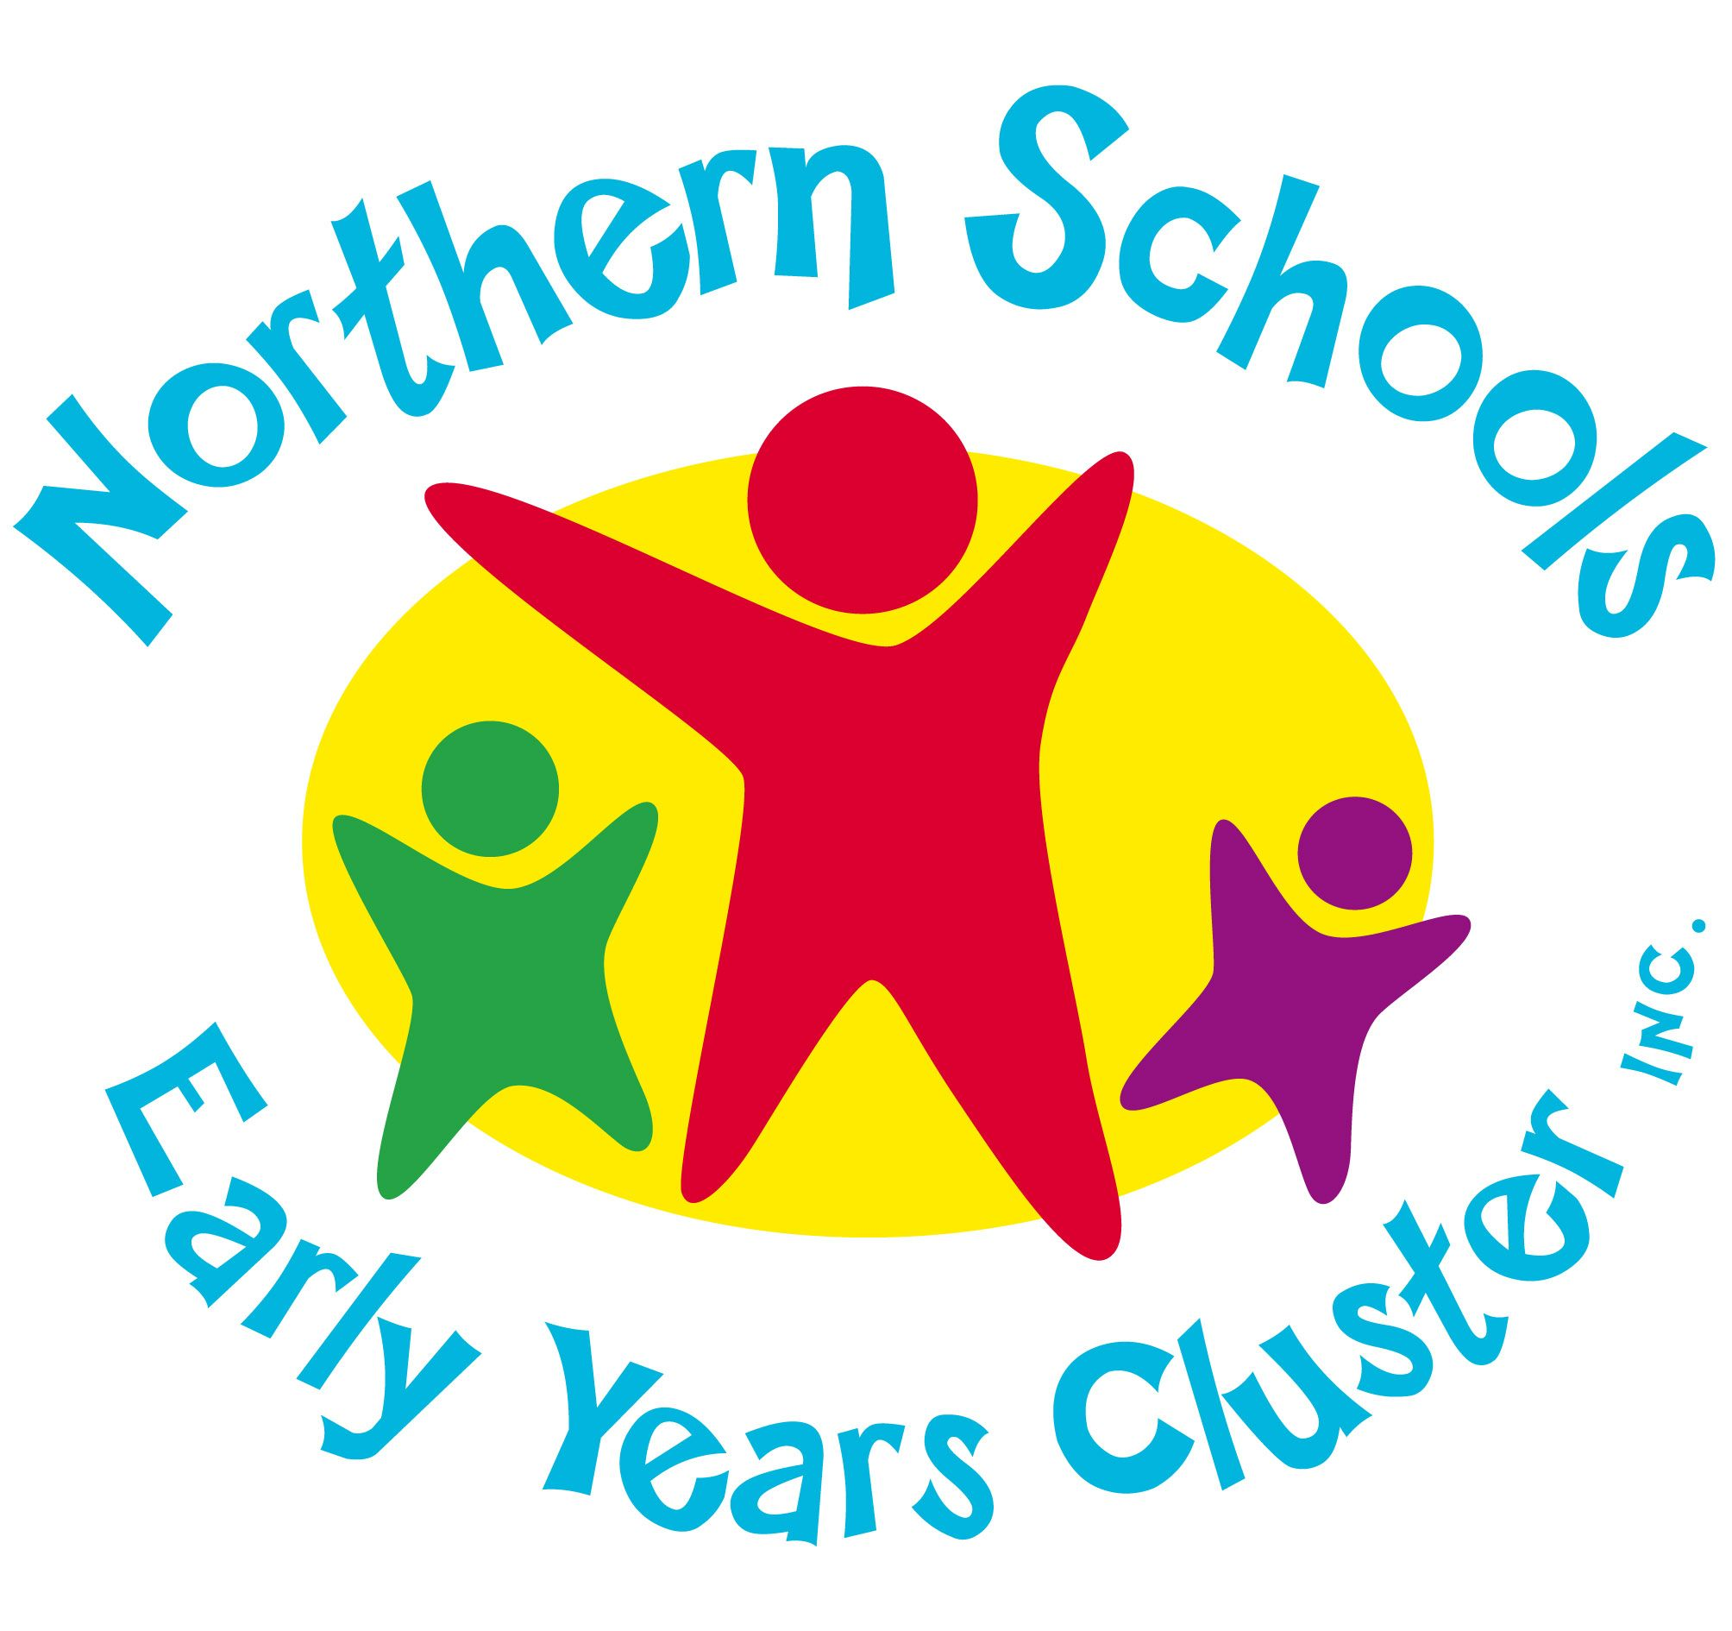
Office: 208A Hilton Street Glenroy 3046
Email: office@nseyc.org.au
Telephone: 9306 1662

APPLICATION FOR THREE-YEAR-OLD KINDERGARTEN - 2022

PREFERENCE OF KINDERGARTEN
(Please tick preferences)
- Belle Vue Park Kindergarten □ Dallas Primary School Kindergarten
- Broadmeadows Primary School Kindergarten □ Glenroy Central Kindergarten
- Bethal Primary School Kindergarten □ Lorne Street Kindergarten
- Meadows Primary School Kindergarten □ Moreland Kindergarten
- Willowbank Primary School Kindergarten
- Will Will Rook Kindergarten
- York Street Kindergarten
- Upfield Kindergarten

CHILD’S DETAILS:

Surname: ___
Office Use Only

Date Enrolled: ___________
- Early Start
- $25.00
Enrolment /Admin Fee
(Non-refundable)
- Birth Certificate
- Immunisation Record (UTD)
- Fee Payment
Rec: ___________
Date: __________
Siblings Enrolled at Primary School
Yes / No
Surname: _____________

Given name: ____ ___

Preferred name: __ ___

Date of birth: Country of birth: _________________
Date arrived in Australia (if applicable): __________ _
Language(s) spoken at home:

Address: ___

Postcode: ___
Gender of child: Male / Female / Other (please circle)

Is your child Aboriginal and/or Torres Strait Islander? (Please tick one box)
- Yes, Torres Strait Islander
- Yes, both Aboriginal and Torres Strait Islander
- Yes, Aboriginal
- No, neither / prefer not to specify

PARENT/GUARDIAN’S DETAILS:

Full name of parent/guardian 1: | Full name of parent/guardian 2:
Telephone:  - Home_____________________________  - Work ___________________________  - Mobile __________________________ | Telephone:  - Home_______________________  - Work _____________________  - Mobile _____________________
Email: | Email:
Relationship to child: | Relationship to child:
Occupation: | Occupation:
Country of birth: | Country of birth:
Language(s) spoken at home: | Language(s) spoken at home:

Child resides with: ____________________
(provide details if different to parent/guardian details above)

Name: phone: ___________________________

Address: ___________________________

Does the child have a medical condition (allergy, asthma, anaphylaxis etc)? Yes / no (circle)
If yes, please provide details:
__________________________________________________________________________________________________________________________________________________________________________________________________

I give permission for NSEYC to share information with the central enrolments of the local council for enrolment purposes. Yes / No (circle)

Please note:
Your child cannot commence in the three-year-old program until they turn three years old. Children are required to turn 3 by 30th April.

In order for your enrolment to be accepted, you will need to pay a $25.00 enrolment fee. You do not have to pay this fee if you are eligible for the kindergarten fee subsidy.

You can do this by depositing the money in the NSEYC bank account. A receipt can be provided upon request.
The banking details are:
Bank: CBA Dallas Name: Northern Schools Early Years Cluster Inc. BSB: 063 229 Account number: 1040 4794
Please ensure that you write your child’s name/year as a reference.

